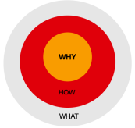

For every story we need these three components to craft the narrative.

**Why:**

Why do you do what you do? Why should someone care about this? Try to get to the deeper motivation often it will involve a personal story or connection.

**How:**

Specifics are always good and should easily connect to the why and easily lead toward the what. This is a good place to focus on the experience people are having

**What:**

In our world this is more about what change are you seeking or what improvement in people’s lives or in a particular system are you trying to achieve. This does not have to be a big thing but it is important to be able to tie it in some way to the shared vision/purpose and higher level outcome goals.

1) As a first step ask yourself what are the three things I want people to know after they read or watch this? These then are the themes.

2) Next, think about who would be the best person/people to talk about each theme.

3) In addition to the people, what other content can help tell the story and where can I get that. Do I need to create it myself in some way or is it available in some form now.